**Assignment 6**

**Name: Mudit Mohit**

**Enrolment No.: BT21GCS057**

**Section: B2**

**Question:**

**Write a program to sort an array of integers using the Quick sort and Merge sort. Analyze your program over the following conditions:**

**1. List is in sorted order**

**2. List is in unsorted order**

**3. What is the best-case and worst-case complexity of both programs?**

**# QuickSort**

**Code:**

def partition(arr, beg, end):

  pivot = arr[end]

  i = beg - 1

  for j in range(beg, end):

    if arr[j]<=pivot:

      i = i + 1

      arr[i], arr[j] = arr[j], arr[i]

  arr[i+1], arr[end] = arr[end], arr[i+1]

  return i+1

def quickSort(arr, beg, end):

  if beg<end:

    p = partition(arr, beg, end)

    quickSort(arr, beg, p-1)

    quickSort(arr, p+1, end)

arr = []

size = int(input("Enter the size of the array: "))

N = int(input("Enter the length of the array: "))

for i in range(N):

    elem = int(input(f"Enter the {i+1} element of the array: "))

    arr.append(elem)

print("The Unsorted Array is:", arr)

quickSort(arr, 0, N-1)

print("The Sorted Array is:", arr)

**For Unsorted List Output:**

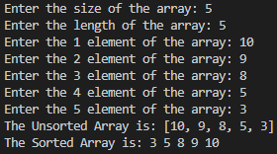

**For Sorted List Output:**

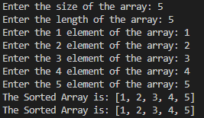

**Best Case Time Complexity: O(nlogn)**

**Worst Case Time Complexity: O(n^2)**

**# Merge Sort**

**Code:**

def merge(a, low, mid, high):

    left = a[low:mid + 1]

    right = a[mid + 1:high + 1]

    i = j = 0

    k = low

    while i < len(left) and j < len(right):

        if left[i] < right[j]:

            a[k] = left[i]

            k += 1

            i += 1

        else:

            a[k] = right[j]

            k += 1

            j += 1

    while i < len(left):

        a[k] = left[i]

        i += 1

        k += 1

    while j < len(right):

        a[k] = right[j]

        j += 1

        k += 1

def mergeSort(arr, l, r):

    if r > l:

        m = (r + l) // 2

        mergeSort(arr, l, m)

        mergeSort(arr, m + 1, r)

        merge(arr, l, m, r)

arr = []

size = int(input("Enter the size of the array: "))

N = int(input("Enter the length of the array: "))

for i in range(N):

    elem = int(input(f"Enter the {i+1} element of the array: "))

    arr.append(elem)

print("The Sorted Array is:", arr)

quickSort(arr, 0, N-1)

print("The Sorted Array is:", arr)

**For Unsorted List Output:**



**For Sorted List Output:**



**Best Case Time Complexity: O(nlogn)**

**Worst Case Time Complexity: O(nlogn)**